To do:

* ~~Interpolate F1 for slac_e142.csv, slac_e154.csv, psolv_e01012_g1g2.csv~~
* ~~Add g2 data from E97103~~
* ~~Fit g1f1 DIS data with neutron form from zheng thesis~~
* Fit g1f1 resonance data with breit-wigner distribution - should be able to get Q2 dependence by plotting the 1232 peak vs Q2

Tuesday August 20, 2024 (2)

* Plotted M vs Q2, along with k and gamma from floating M fits
* Should change B-W form and refit delta peaks
* Should share with Richard after doing this

Monday August 19, 2024 ()

* Substituted beta from cubic DIS fit for the original fit - works well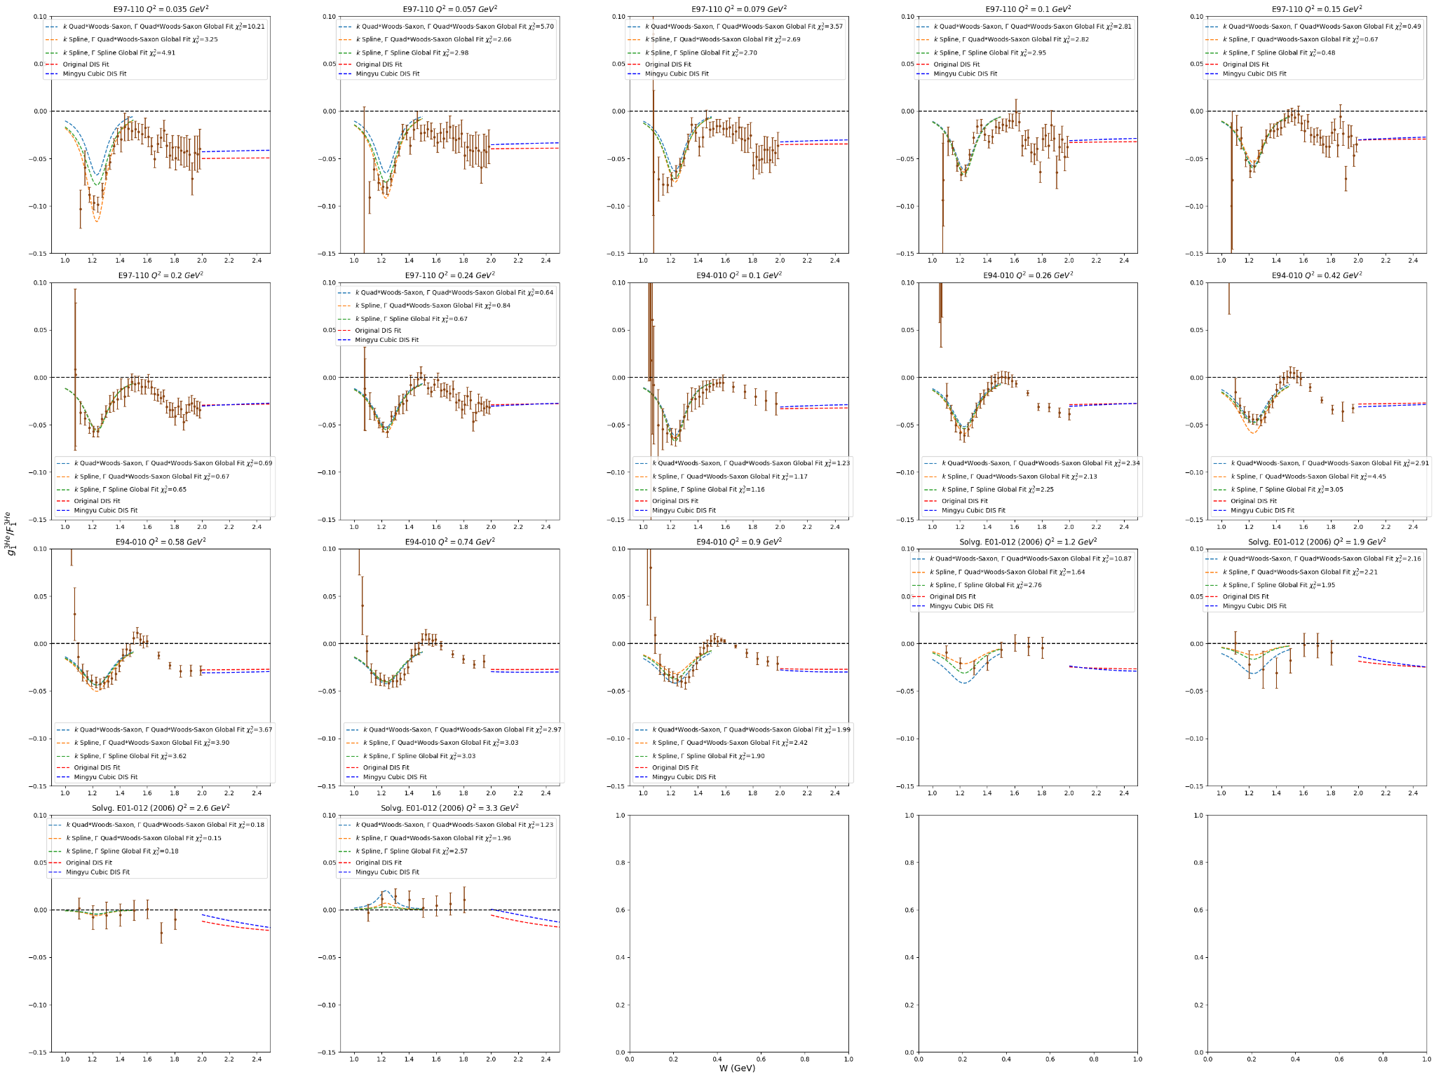

Wednesday August 7, 2024 (3)

* **Calculated W for SLAC E154, E142 and JLab E97103 and HERMES and Mingyu with 3He nucleus mass - need to use nucleon mass**
  + Fixed them
* Doesn’t seem to have changed the fits for DIS and resonance at all
  + Quadratic form 2 fit for original data (no mingyu):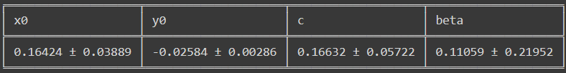
  + Cubic form fit for original data (no mingyu):
  + 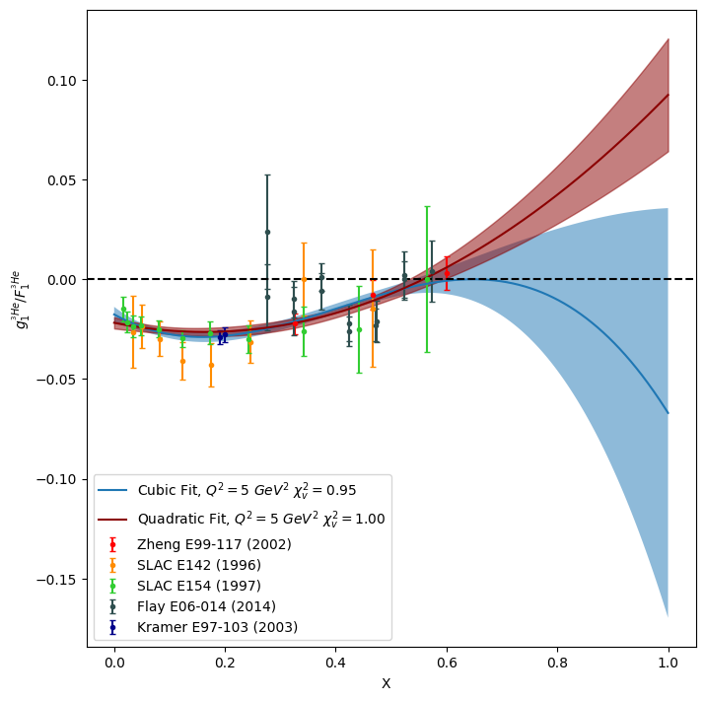
  + Quadratic form 2 fit with Mingyu data: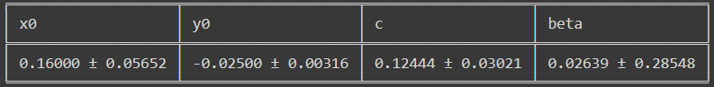
  + Cubic form fit with Mingyu data: 
  + 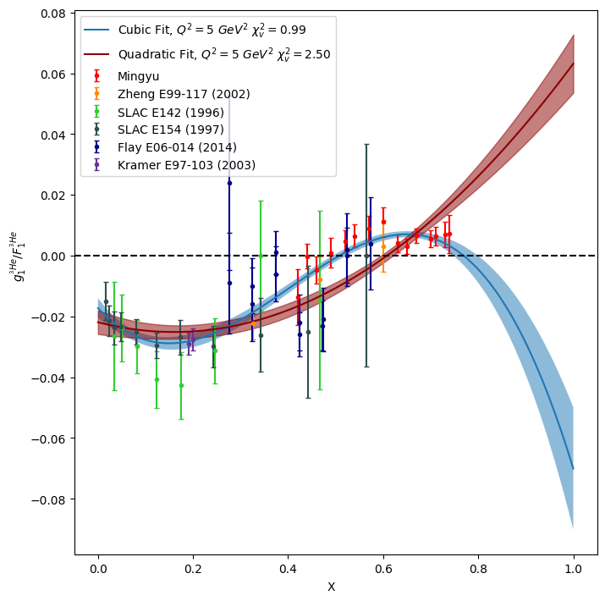
* Added notes from meeting with Xiaochao to the Slack channel
  + Plot M versus Q2 from floating mass fits for delta peaks
  + Fit 4 red gamma points as a constant and add the result (with uncertainty) at high Q2 to restrict fit at high Q2
  + For gamma fit, try the Woods-Saxon fit with P1=0.5 and P2=0.1 - try to push curve to lower Q2
  + Change Breit-Wigner so k represents the actual peak:
  + substitute with k_new = k/(M^2 * gamma^2)
  + Several ideas for connecting DIS fit to resonance:
  + fit the residual between delta fit and actual points at the middle region (W=1.5) and add to fit in order to hit those points
  + Need a smooth function to connect DIS to B-W function at W=1.8 - maybe linear and add in wiggles for lower Q2 (Q2=0.1 & 0.5) bins with structure.
  + DIS fit doesn't line up nicely at lower Q2 bins - maybe add another beta term that disappears at higher Q2.
  + Cubic fit for Mingyu works well for these bins, but bad behavior for high x (becoming negative)
    - Avoid cubic fit - use beta value with the quadratic

Tuesday August 6, 2024 (3.5)

* Rearranged update slides for today’s meeting - swapped “nuclear potential” for “woods-saxon”
* Made function to convert x to W - x->1.0 is the resonance region limit
* Presented at meeting - jian-ping says I should use the floating M fits for low Q2 bins and the gamma fit should be an increase to 0.25 and then constant
  + Should add horizontal lines for zero in plots
  + 1.5 and 1.8 resonances are too complex to model most likely - should see how my original DIS fit looks like in resonance region
* Added original DIS fit to plots - seems not bad, should see how other DIS fits look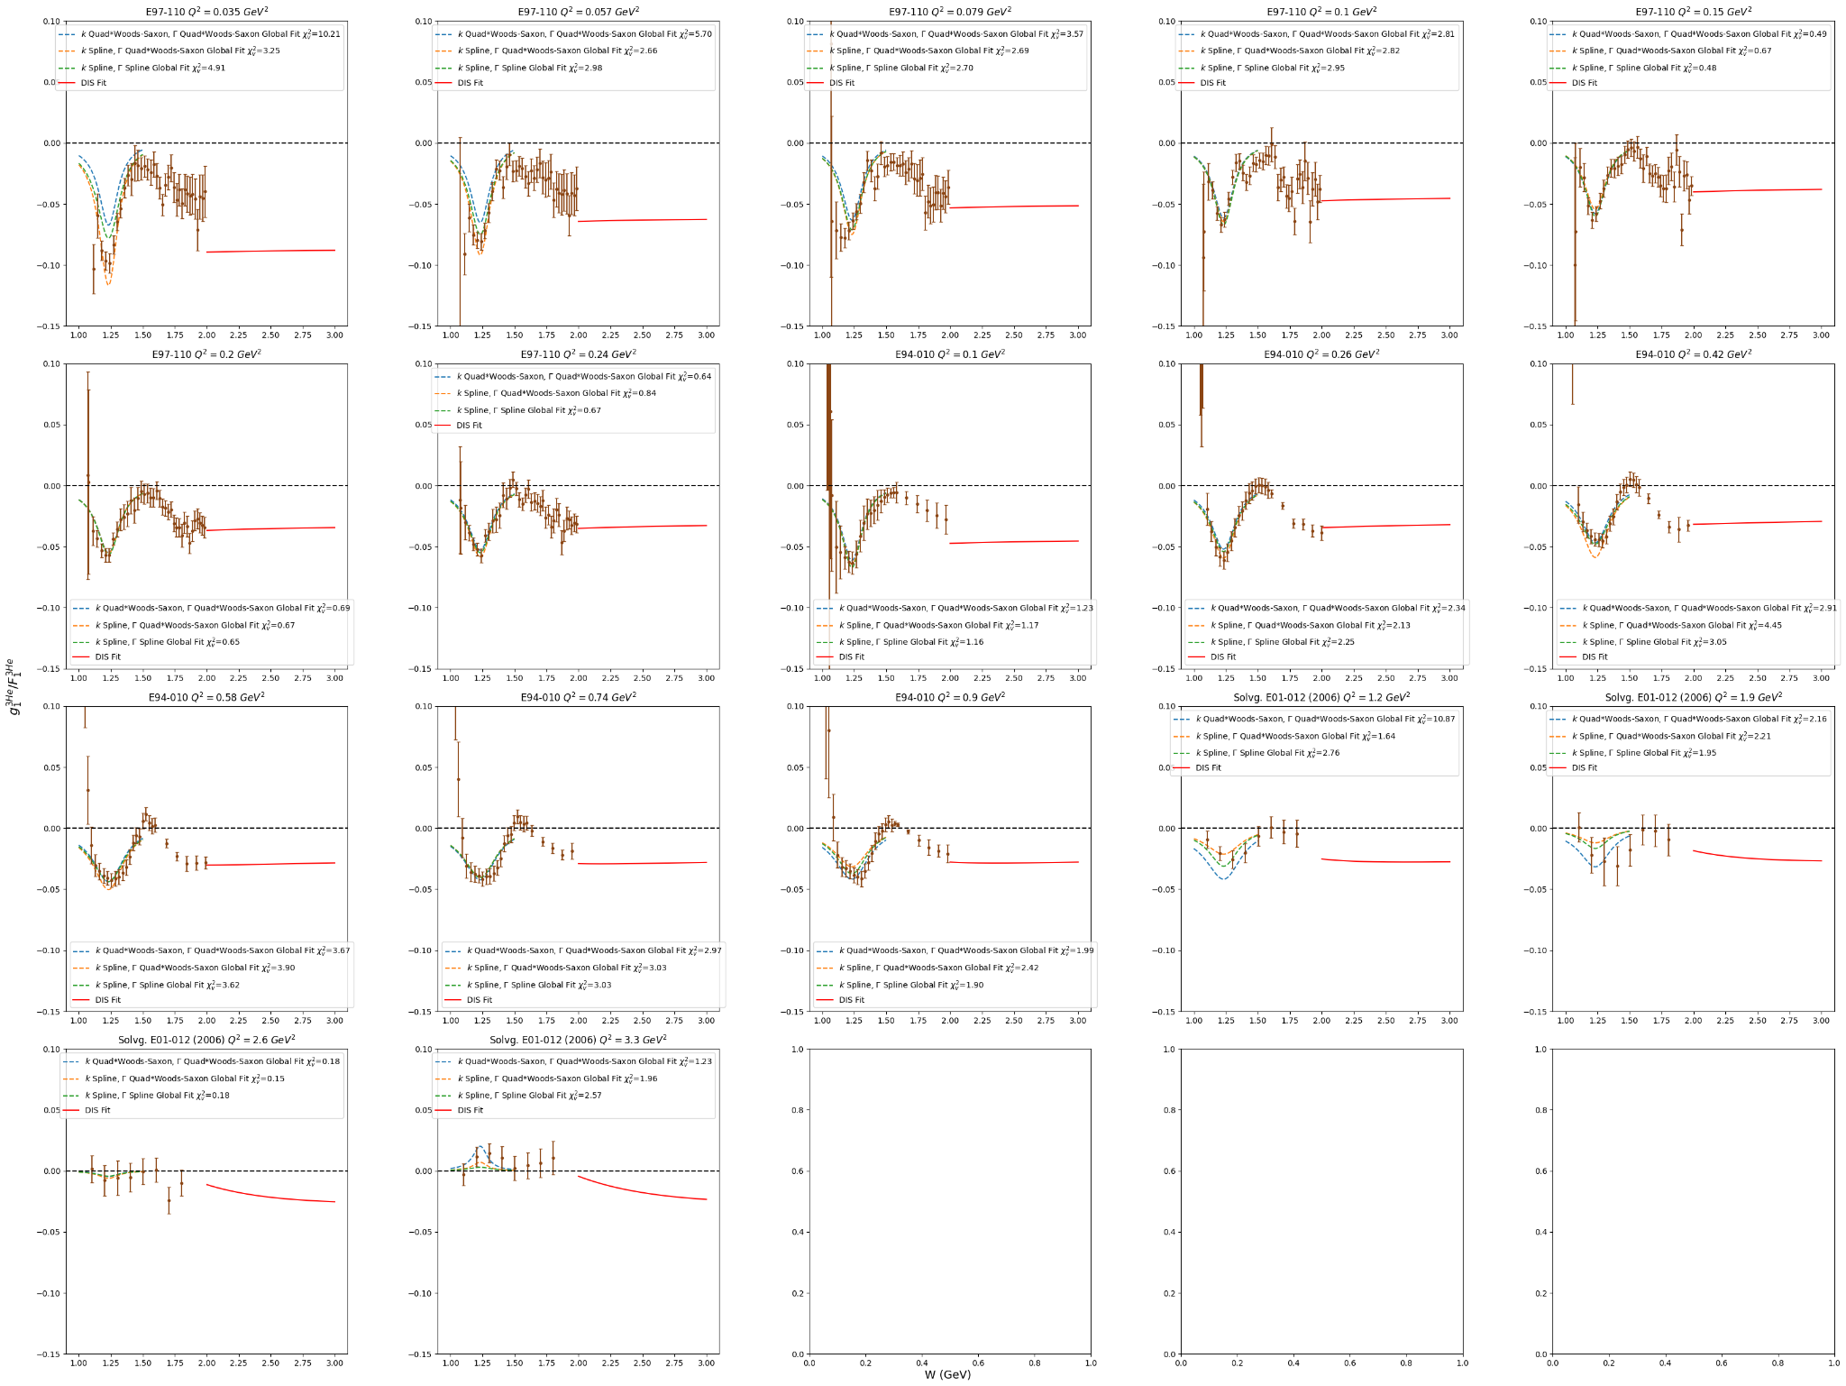

Monday August 5, 2024 (2)

* Xiaochao says these fits look good - need to figure out the next resonance region
  + Try extending DIS fit to W>2 GeV (convert x to W for constant Q2) to see how they connect and if there is more structure to fit - good question for meeting tomorrow
* Mixing spline of k and quad-nucl potential fit for gamma seems best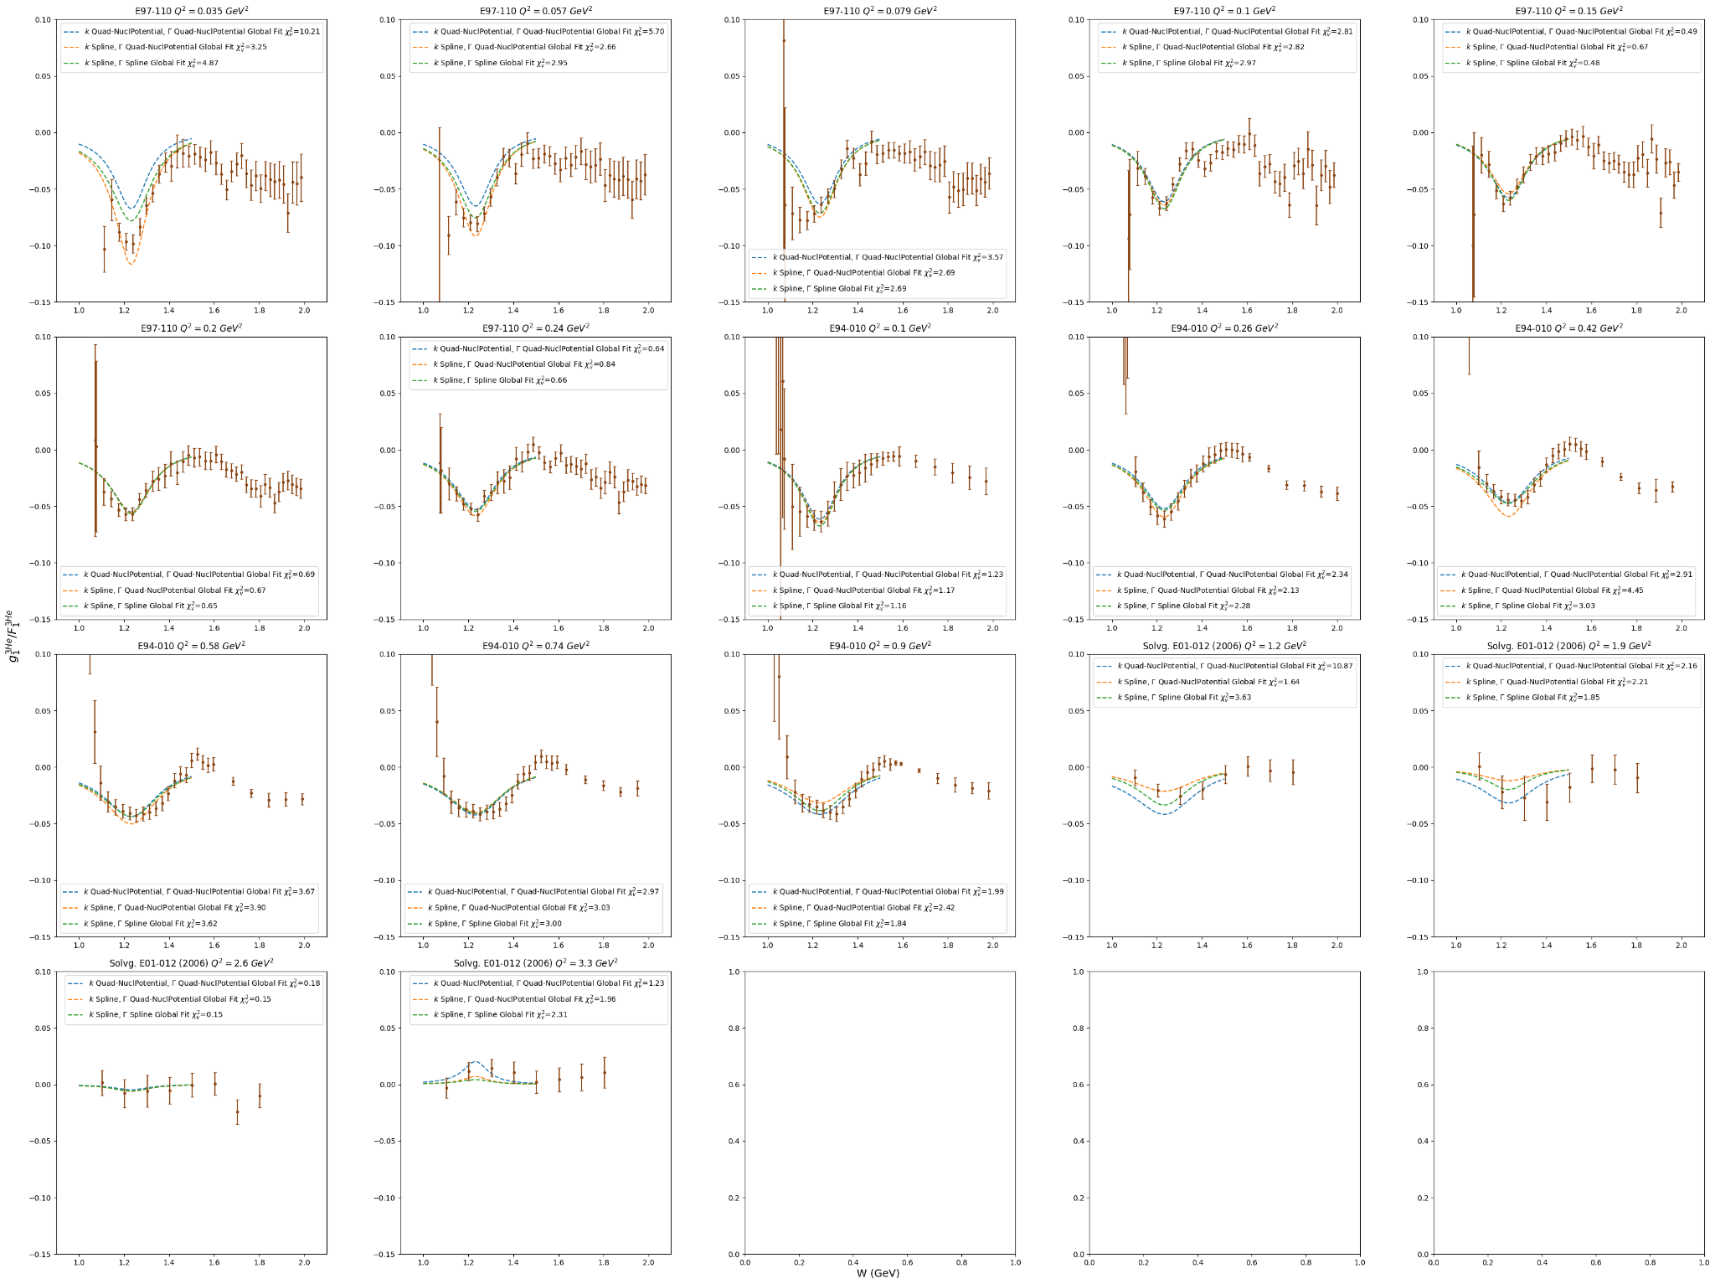
* Should try combining spline for k with quad-nucl. potential fit for gamma - the latter has a lower value at low Q2 -> push peak deeper for lowest bin
* Added constant points from 4.0 to 13.0 GeV2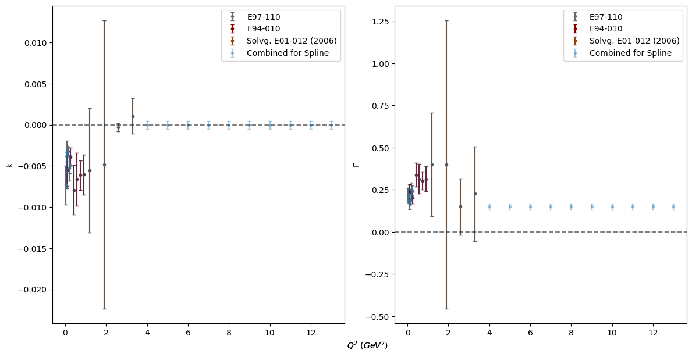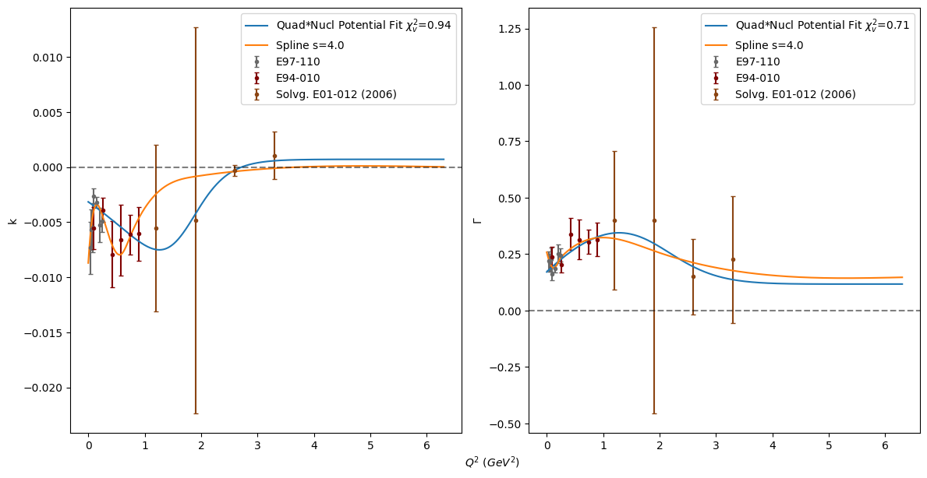

Friday August 2, 2024 (4)

* Tried adjusting p0, p1, p2 for the fits to get better delta peaks - still miss lowest Q2 peak
  + 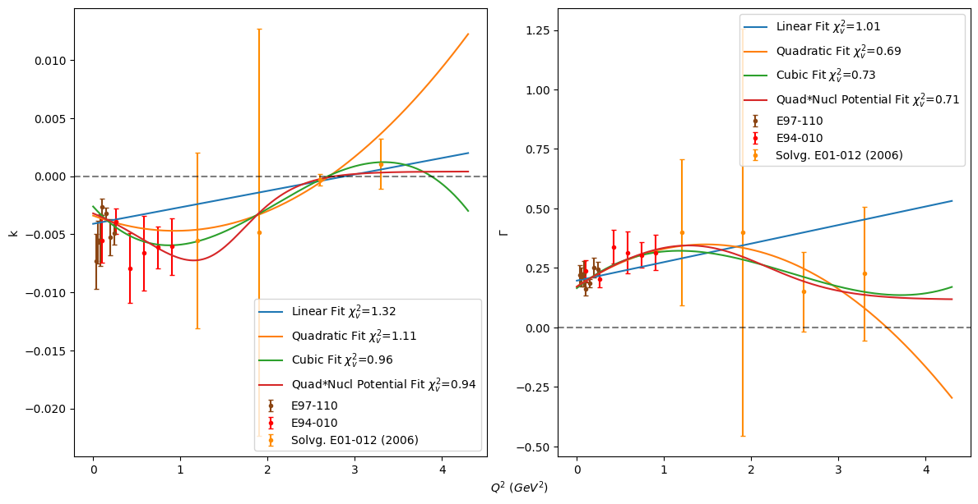
  + 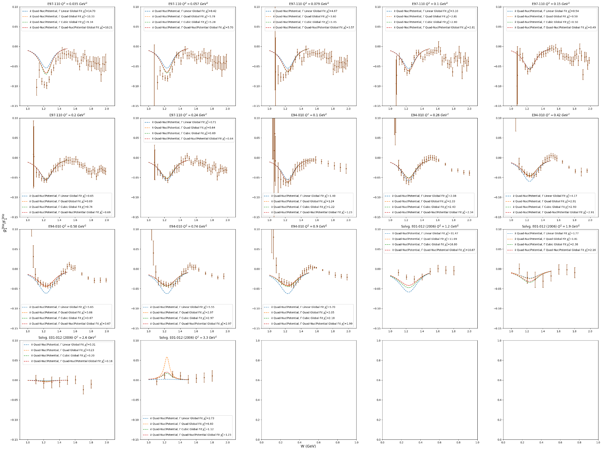
* Xiaochao says to try spline fit - trying scipy.interpolate splrep
  + Doesn’t work with duplicate points for same x - should average these points if I want it to work
  + To get it to stay at zero for high q2, just at a point with low uncertainty at high q2
* Finally able to do spline - I combined duplicate points via weighted average and combined errors according to this stack exchange [post](https://stats.stackexchange.com/questions/71419/average-over-two-variables-why-do-standard-error-of-mean-and-error-propagation)
  + 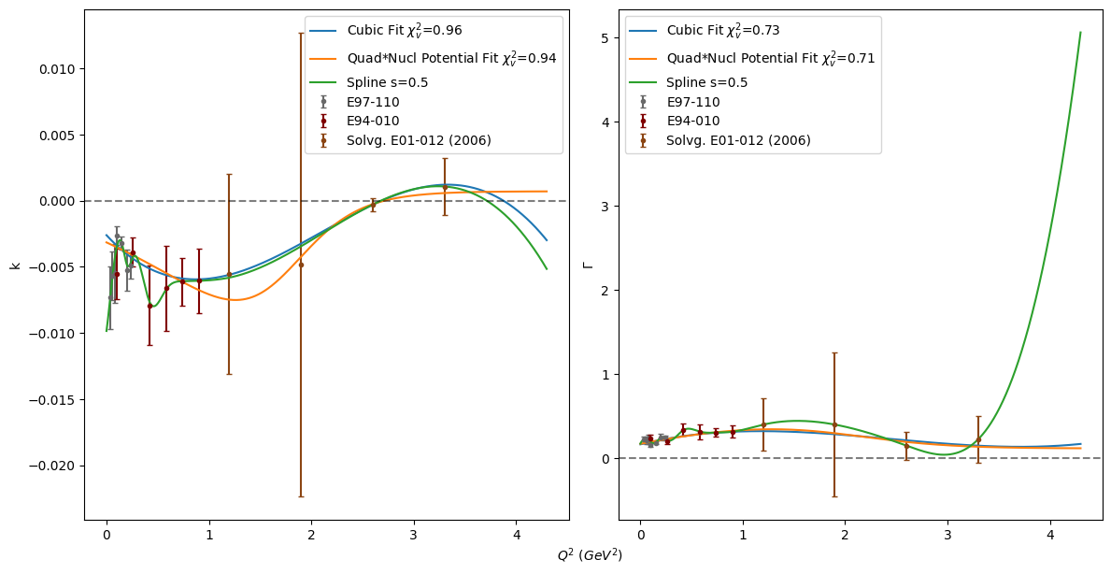
  + Need to add constraint points at high Q2
* Better splines - may need to add more fake points at high q2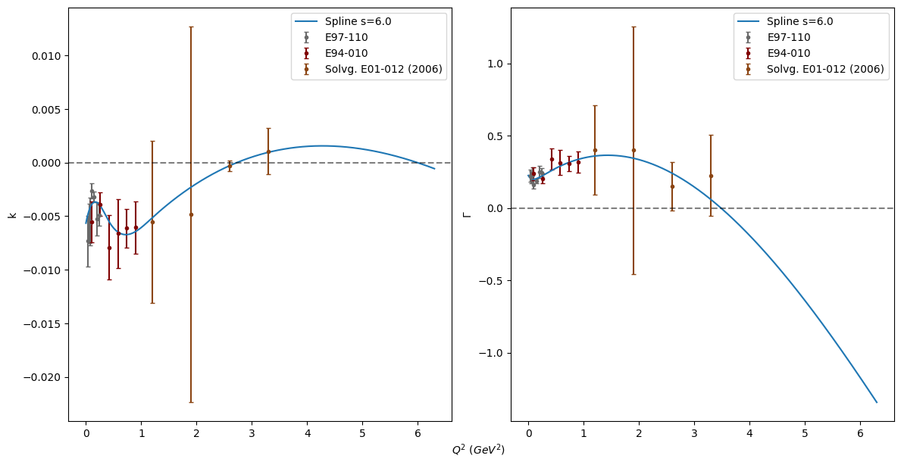

Thursday August 1, 2024 (5.25)

* Tried different constraints for pure nuclear potential fit, but never seemed to get a close fit for all bins
* Xiaochao said the ideal form is ***quadratic times*** the nuclear potential - im dumb
  + Added a constant y0 to this so the fit can decay to a constant value other than zero
* 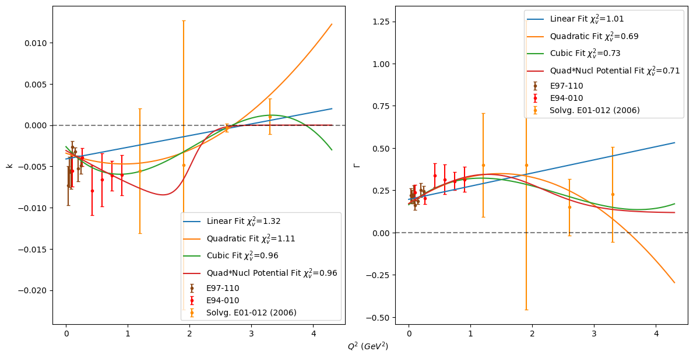
* 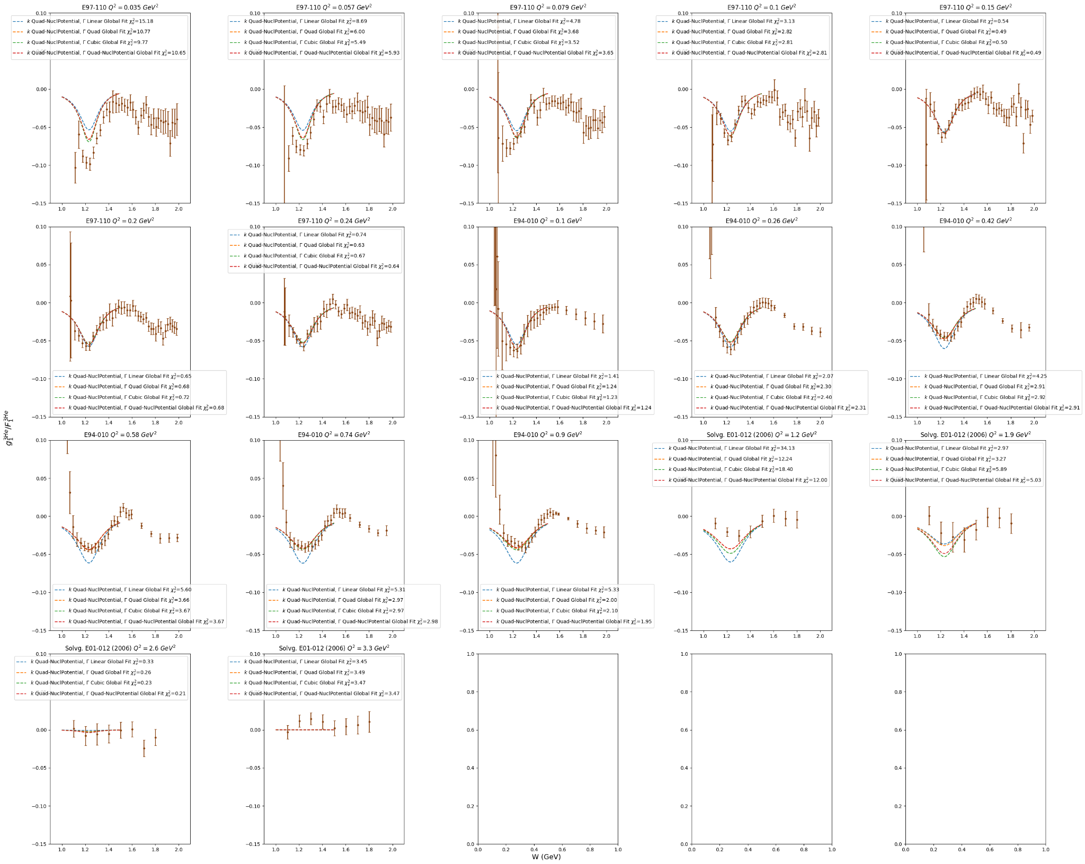

Wednesday July 31, 2024 (3)

* Fiddling with nuclear potential fits for k and gamma still
* Note: if I use the nuclear potential form for k and gamma, the delta peak will become constant at some point, whereas if I use nuclear potential for k and linear fit for gamma I get a positive peak that disappears at higher Q2

Tuesday July 30, 2024 (5)

* Fitted k and gamma again with Solvg. parameters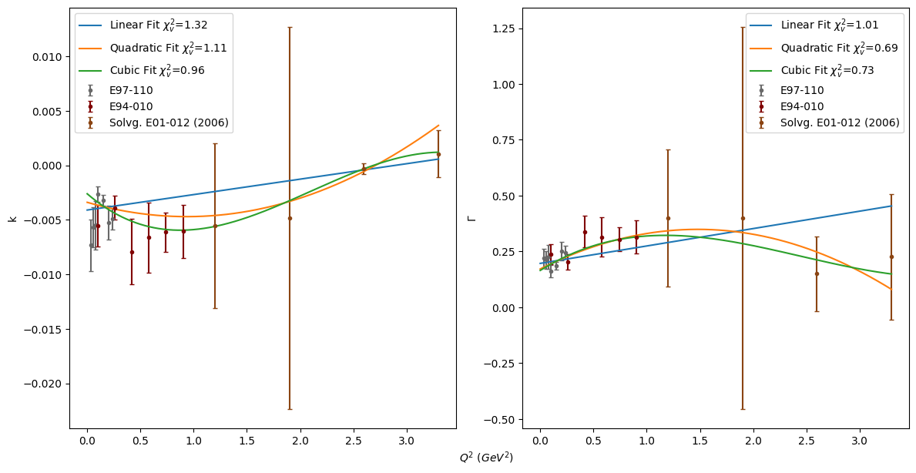
* Tried exponential and cubic*exponential fit for k, but the first failed and the latter overfitted
* Tried quadratic*exponential fit for k but it doesn’t approach zero fast enough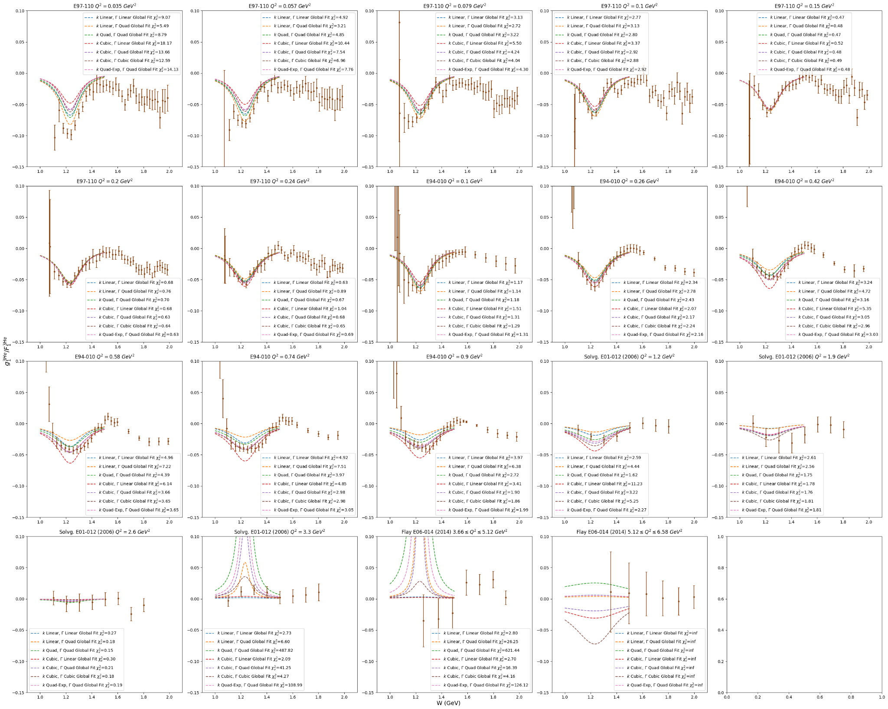
* Presented update to a1n/d2n meeting
  + Xiaochao says k fit may be better fit by nuclear potential form
    - Same for gamma fit
  + May be better to have fit for k to start at constant value (less jump in values for small Q2)
  + Should drop Flay data
* Tried fitting k and gamma with nuclear potential form 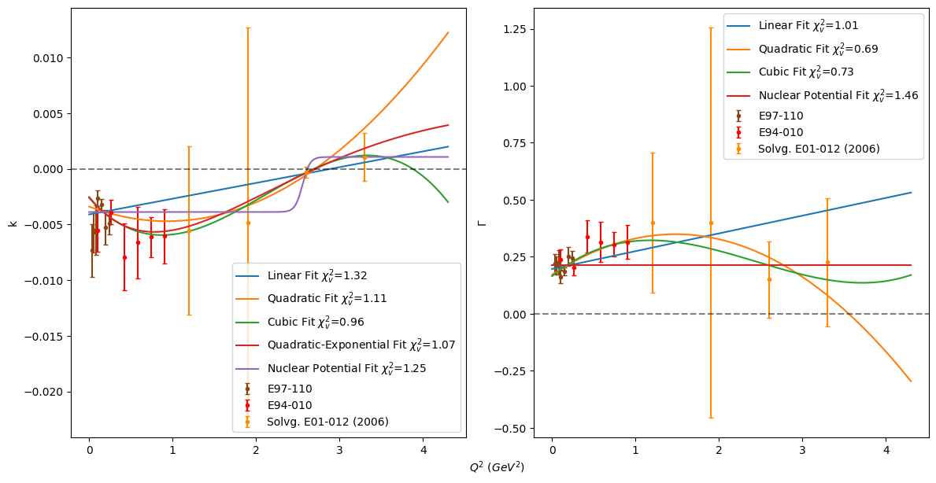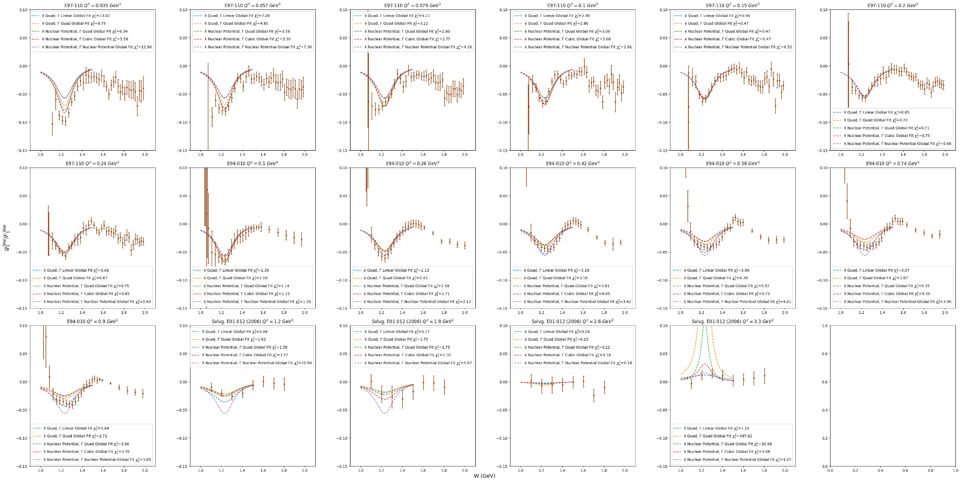
  + Should try k fit with constant y0 of zero and gamma fit with a faster drop

Monday July 29, 2024 (2.25)

* Constrained gamma for Solvg. fits - still have a positive peak for Q2=3.3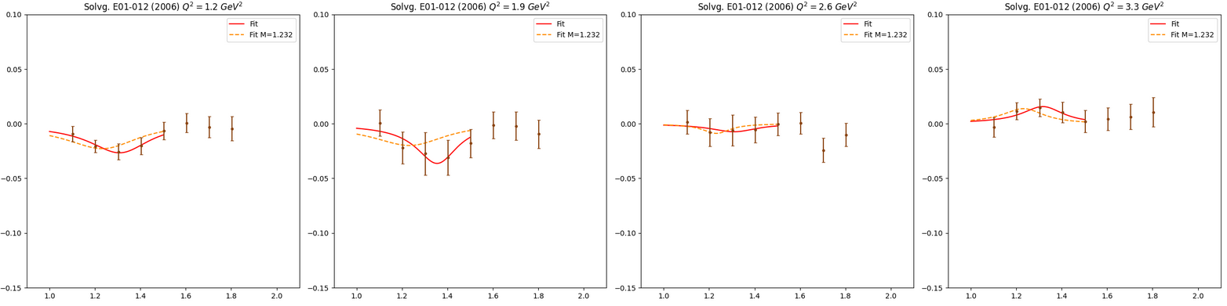
* Changed fitting function so it creates a new dataframe with the parameters
* 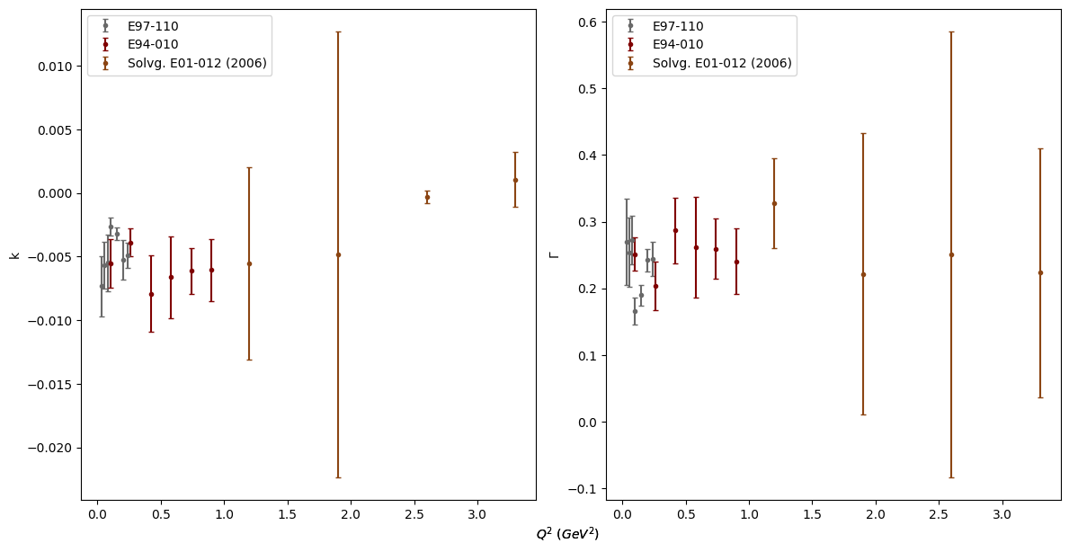
  + K does go to zero

Friday July 26, 2024 (4)

* Did constrained quadratic DIS fit with Mingyu’s data
  + 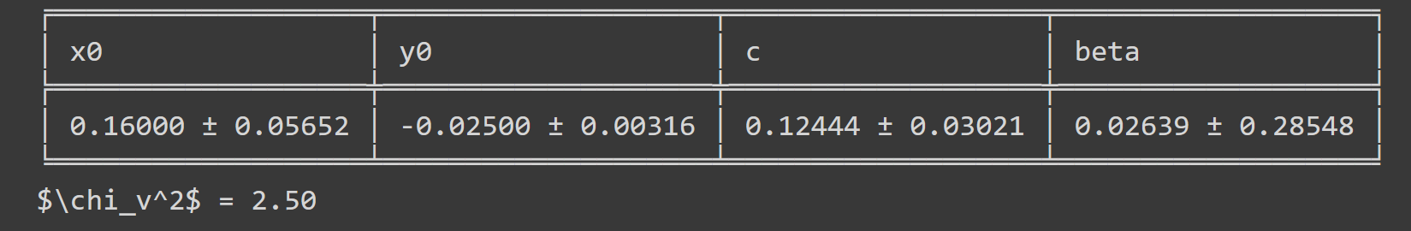
* Tried bounding gamma for Solvg. plots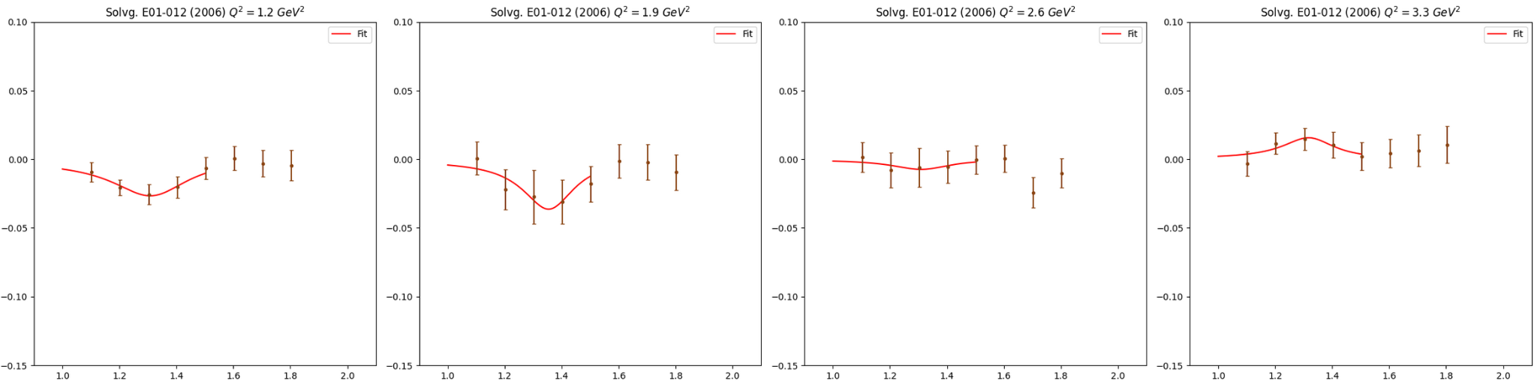

Thursday July 25, 2024 (4)

* Added chi squared function that gets reduced chi squared of fit
* Fitted k and gamma from visible delta peaks with linear, quadratic, and cubic functions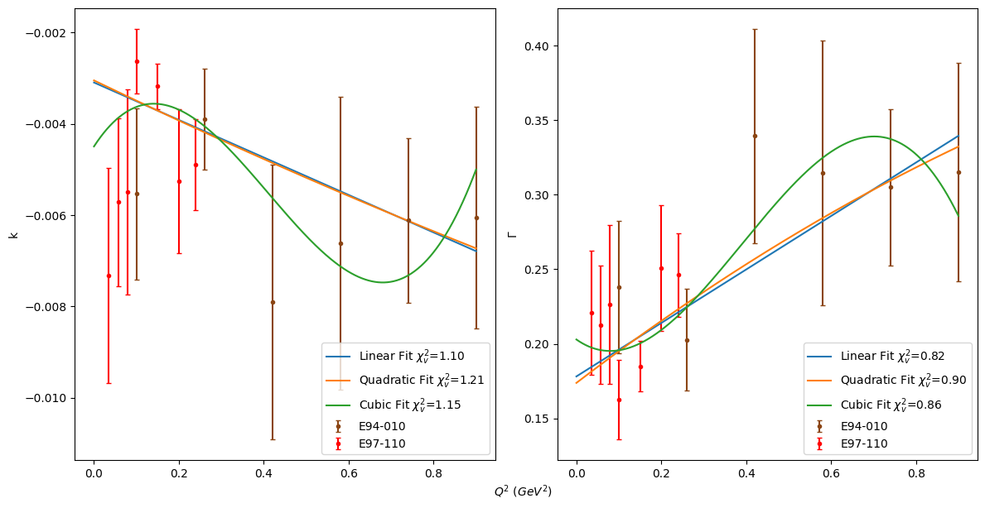
* I want to see what combining these different fits would look like - obviously the linear fit for k and quadratic fit for gamma seem to be the best choices from the chi squared
* 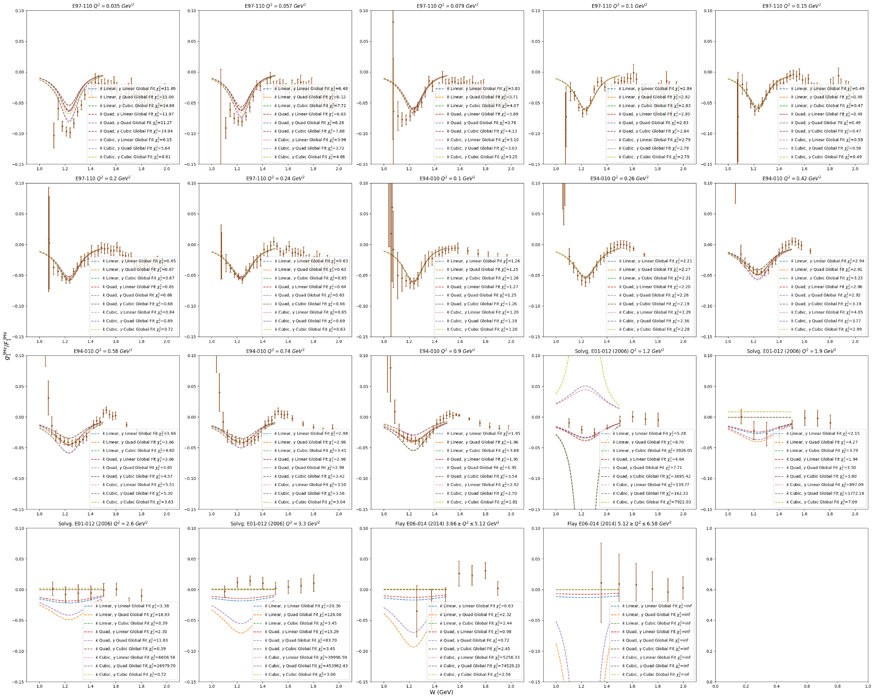
* Think linear fit for both k and gamma has better behavior than linear fit for k and quad fit for gamma - doesn’t deepen dramatically at high Q2
  + Doesn’t fit as well for low Q2, but whatever

Wednesday July 24, 2024 (4)

* E94-010 used M3He for *x* (Slifer thesis)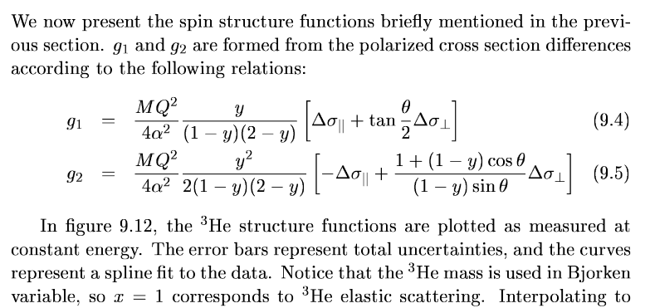
* E97110 used nucleon mass
* Should divide g1 for E94-010 to get per nucleon - plots now look comparable to E97-110
  + Divided g1, g2 and their errors by 3 and saved to csv for e94010
* Shifted order of experiments in g1 and g2 data frames so Solvignon’s data goes before Flay’s - general increase in Q2 in plots
* Did quadratic fit for k and gamma for clear delta peaks (E97-110 and E94-010)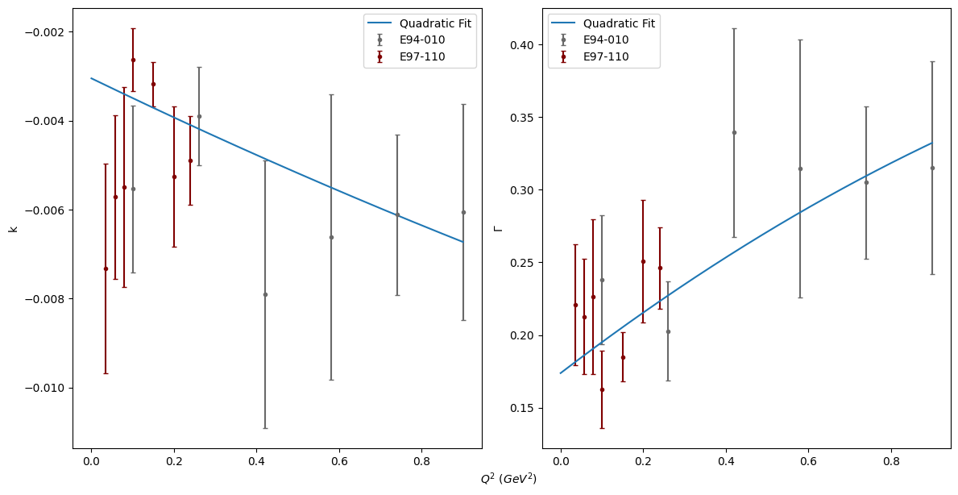
* Next need to check how getting parameters from these functions looks - try to add chi2 too

Tuesday July 23, 2024 (4)

* Attended a1n d2n meeting - presented slides
  + Should re-organize the DIS plots by Q2 - push Solvignon plots to the end in front of Flay
  + Look into multifit for python
  + Add chi squared to fits
  + Should try to constrain the parameters for fits (ex: minimum for quadratic fit for DIS)
  + Check if E94-010 g1 is off by a factor of 3 (nucleon vs. nucleus g1)
  + Refit delta peaks after this and do a fit of k and gamma (follow steps in Slack)
* x=1.0 is resonance region
* DIS fit will join with Resonance fit at some value of x/W depending on Q2

Monday July 22, 2024 (4)

* Added error bars to cubic fit with Mingyu’s data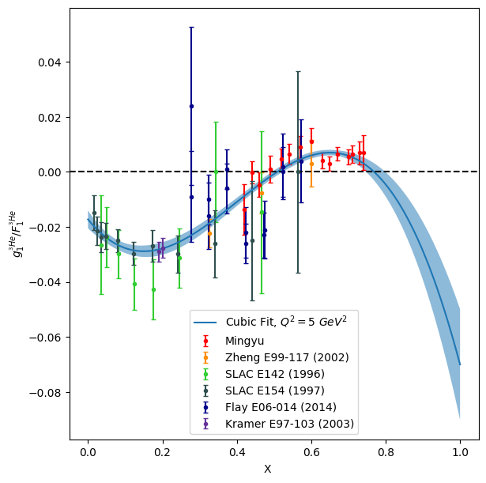
* Did 1440 MeV resonance peak fits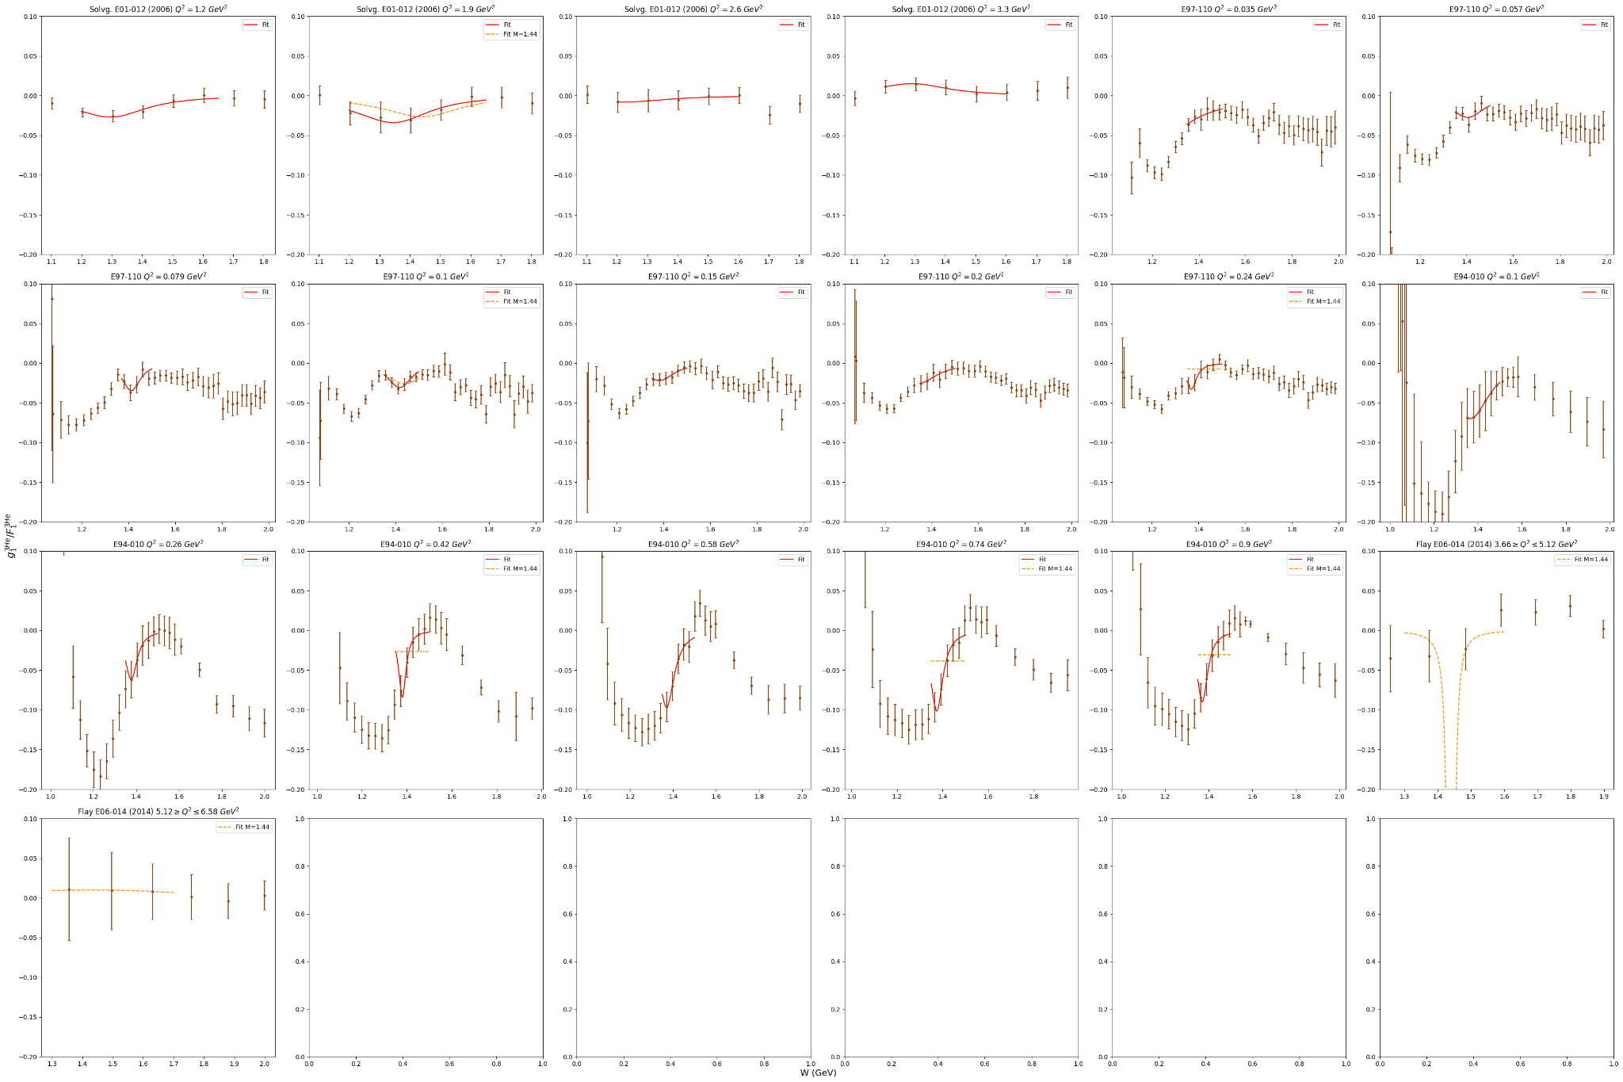
  + Confident with Q2 = 0.057, 0.079, 0.1, 0.15, 0.24 GeV2 bins for E97-110
* Did 1520/1535 MeV resonance peak fits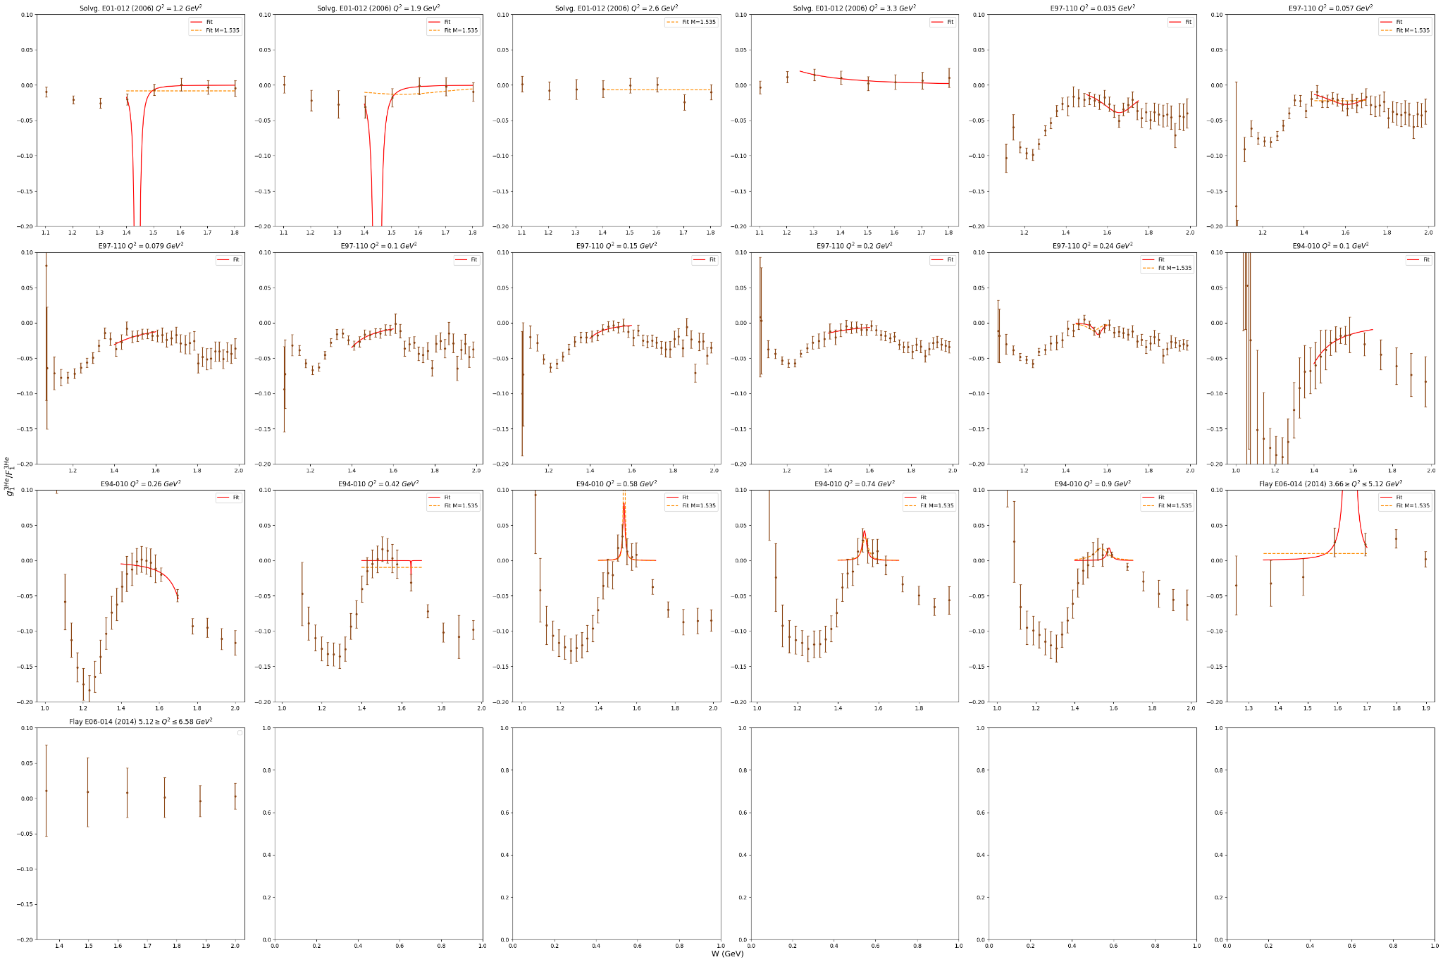
  + Confident with Q2 = 0.035, 0.057, 0.24 GeV2 bins for E97-110
* Did 1675/1680 MeV resonance peak fits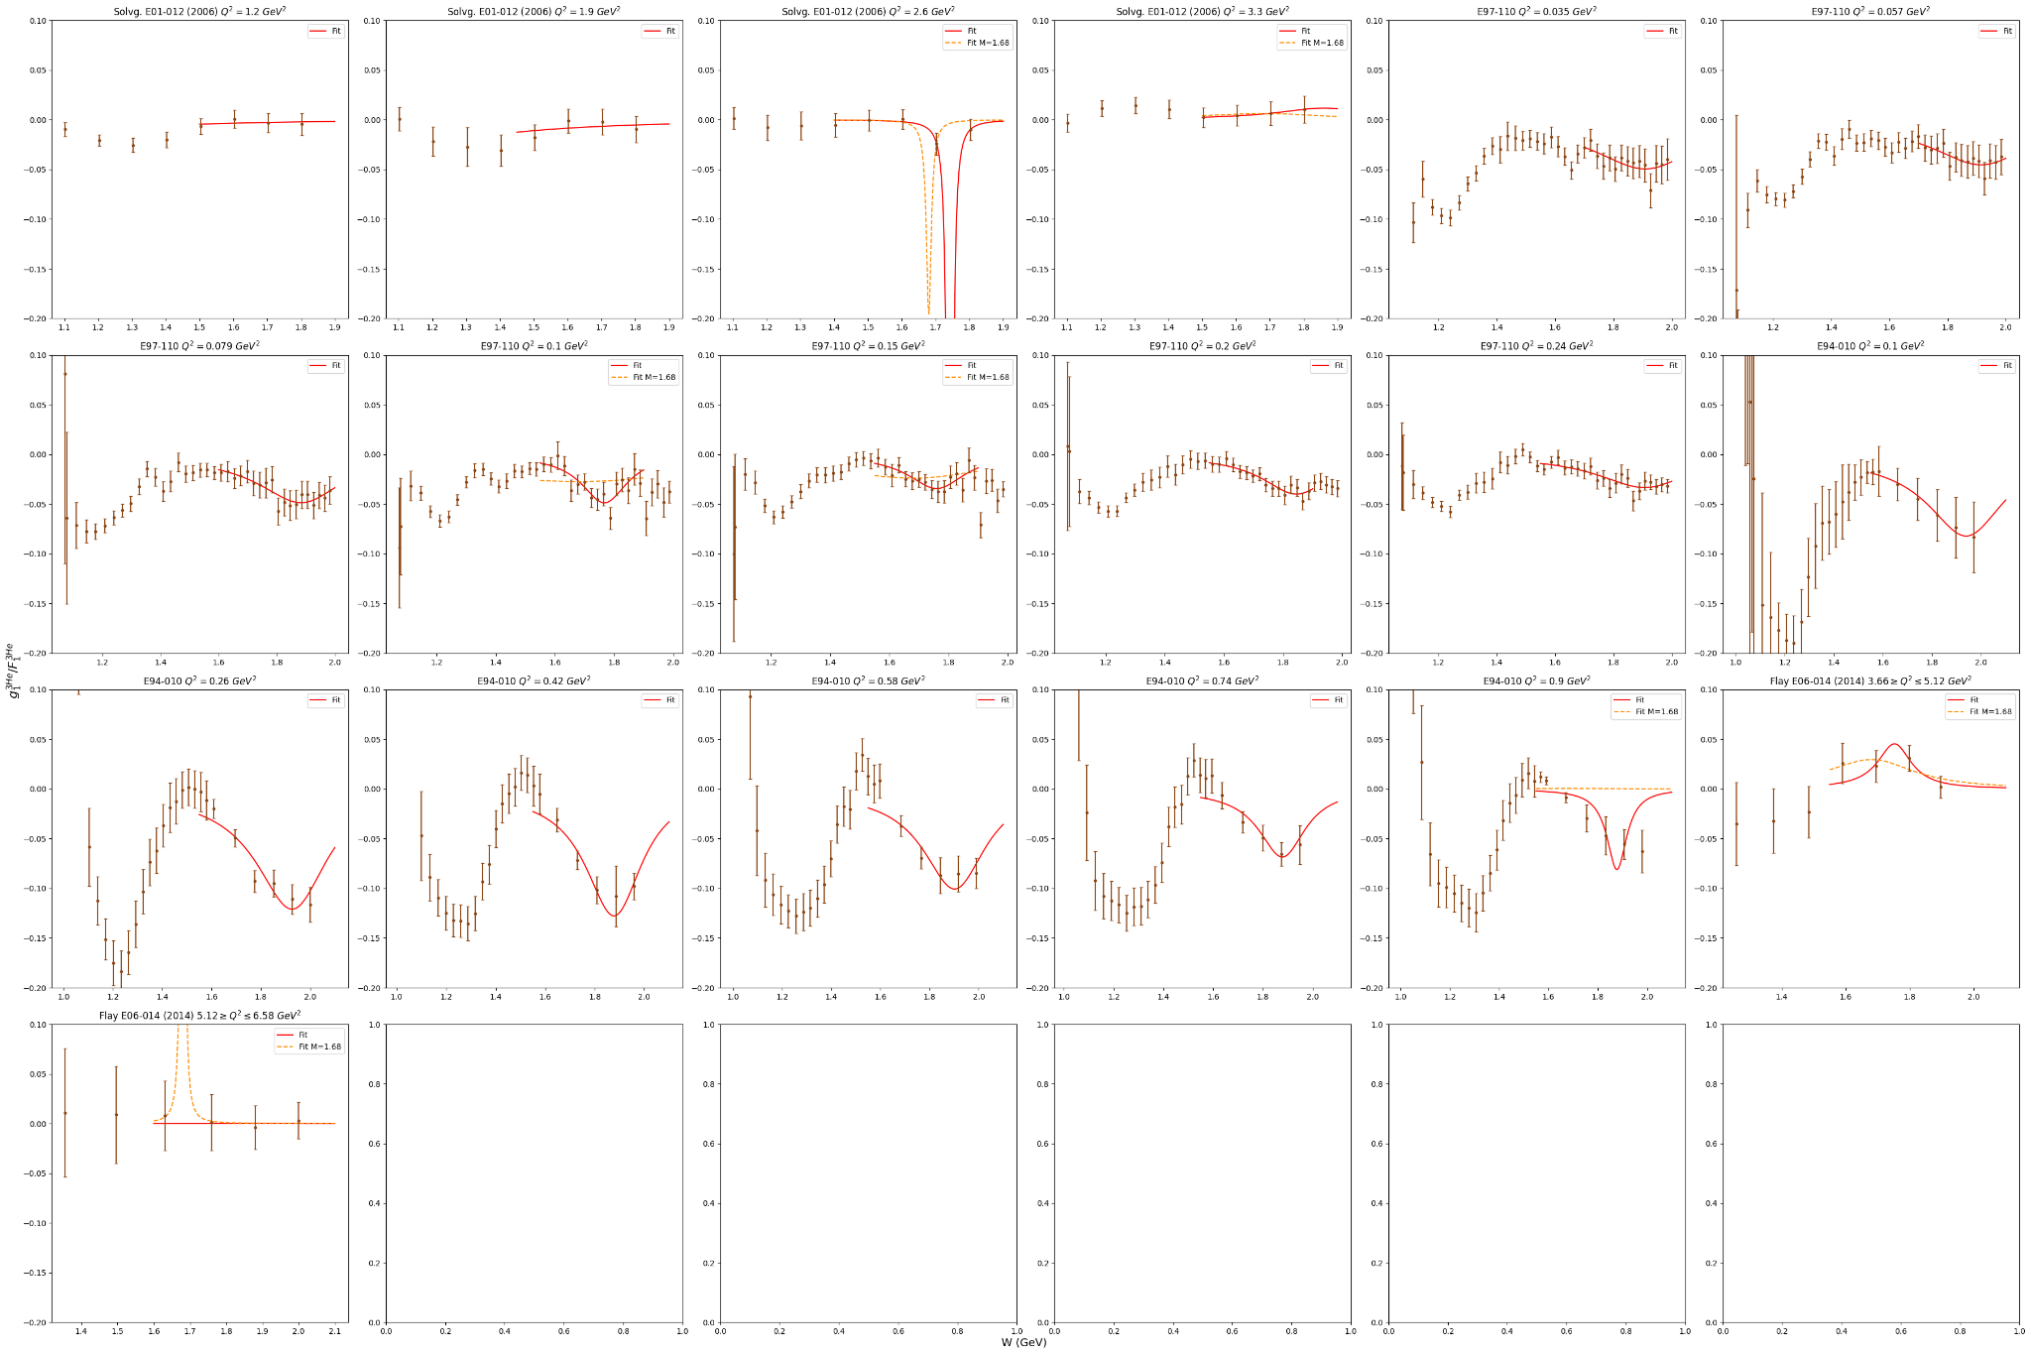
  + Confident with Q2= 0.035, 0.057, 0.079, 0.1, 0.15, 0.2, 0.24 GeV2 bins for E97-110
  + Should see how the parameters from E94-010 line up with the rest
* Plotted all the parameters for fits I thought were good (including E94-010)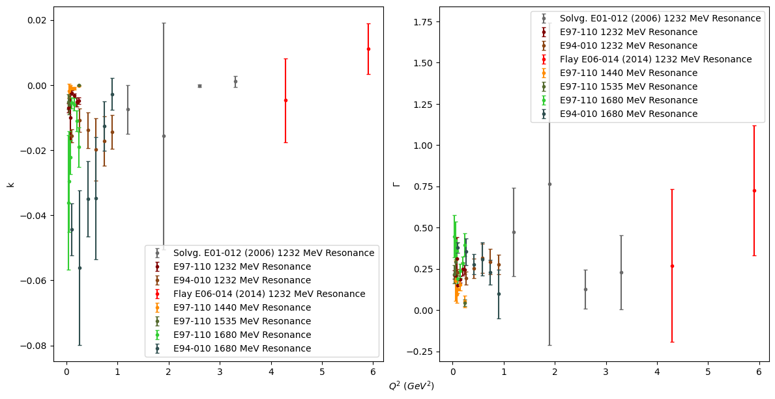
  + Not really sure what to make of the relationship between the parameters and Q2

Friday July 19, 2024 (5.5)

* So far fitting the Roper resonance (1.44 GeV) is difficult - try unique bounds for each Q2 bin
* Modified code so I can choose the bounds for each fit
* Registered for elog
* Found a slideshow with the resonances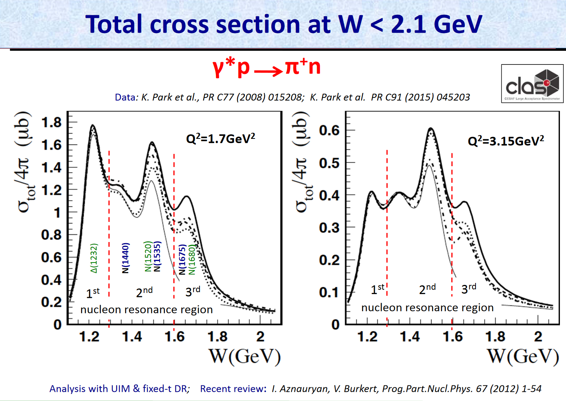
* Can only get decent fits for 1.440 MeV resonance with e97110 - added the parameters to the plot
* Xiaochao says to finish fitting and combining fits by July 30th
  + Try DIS fit with thesis form with Mingyu data
  + Try DIS fit with downward trend
* Fitted DIS with Mingyu’s data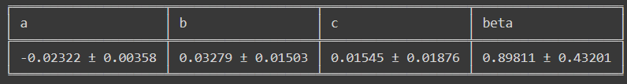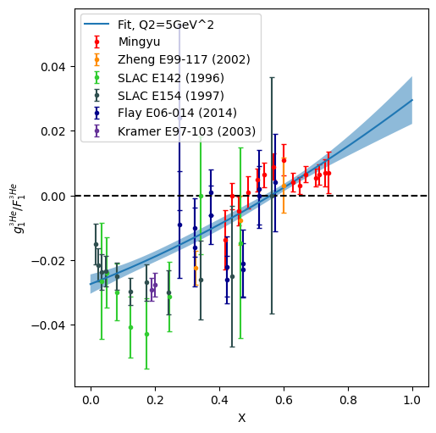
* Fitted with cubic form to get downward trend with Mingyu’s data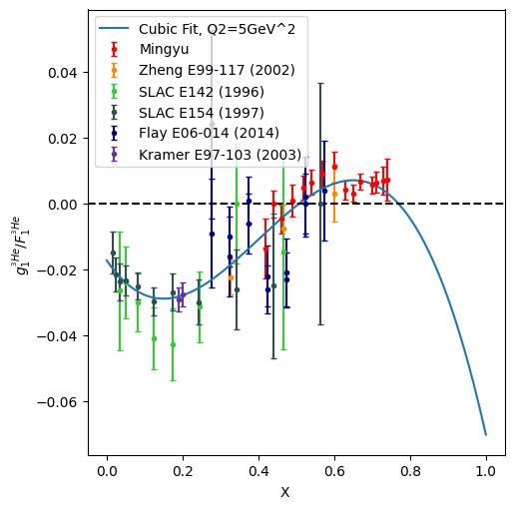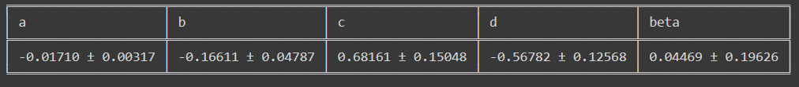
* **Should add error band to this plot**

Thursday July 18, 2024 (2)

* Roper resonance should be at 1440 MeV
* Condensed code for fitting and plotting the resonance region into two functions
* Tried fitting for the 2nd resonance peak (1440 MeV) - need to tune it some more

Wednesday July 17, 2024 (4)

* Fitted resonance data again, this time with M=1.232 (not a floating parameter)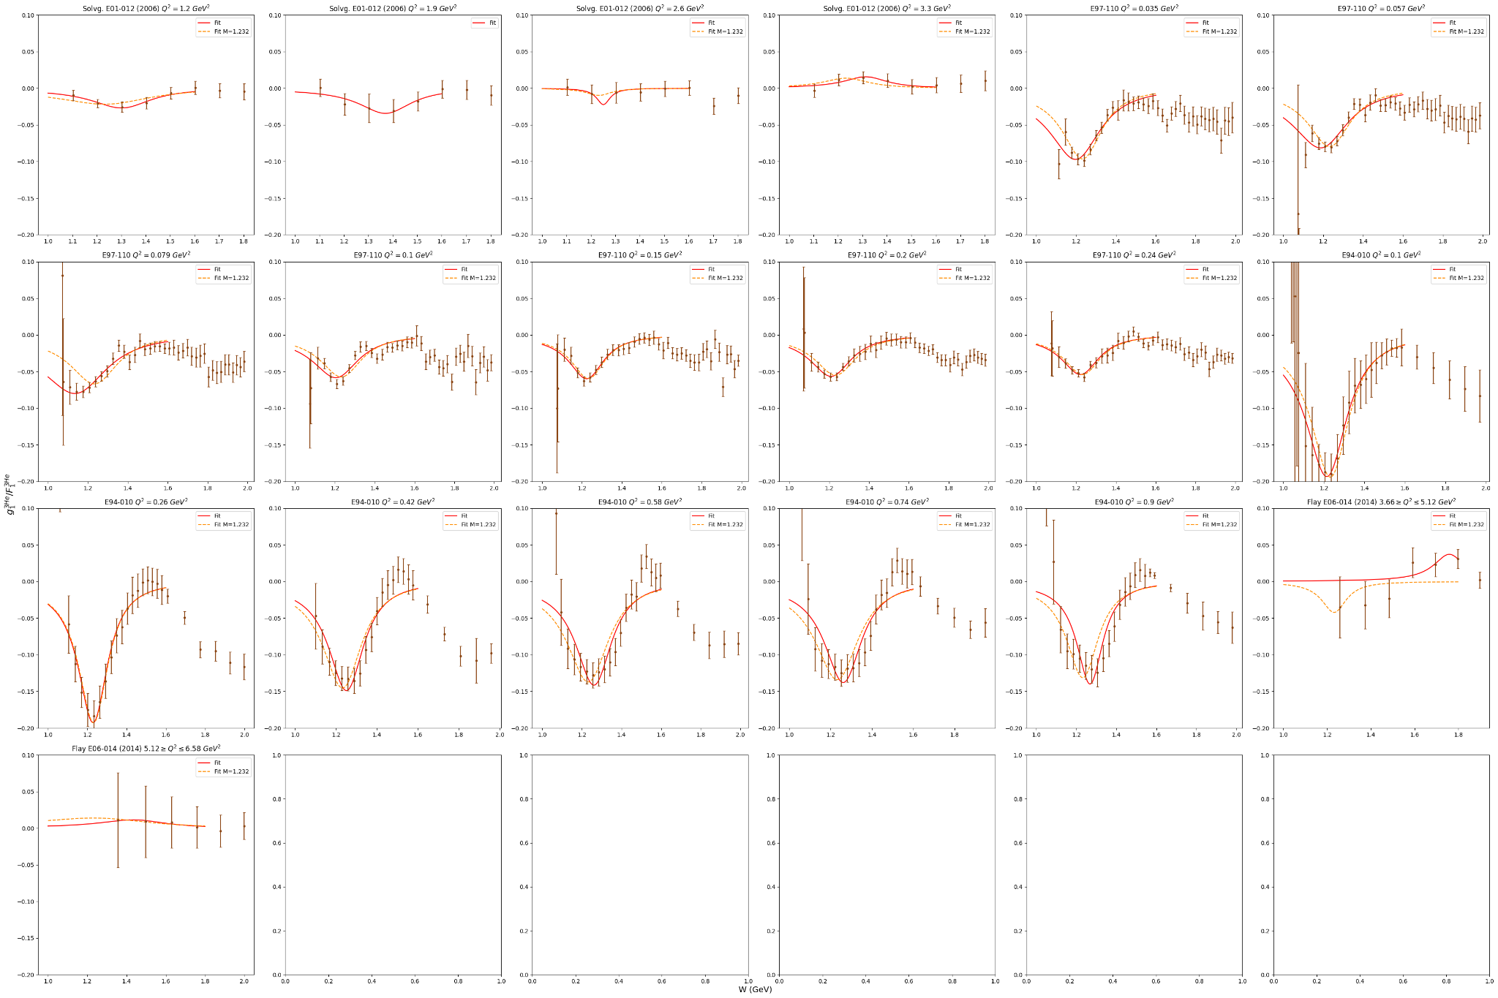
* Xiaochao says this fit does better for the 1232 MeV peak
* Should fit 1.5 and 1.8 regions with floating M value since they are combinations of 2-3 resonances with no fixed M value
  + **Look up “Roper” resonance at 1.5 and 2-3 resonances at 1.8 in PDG**
* Plotted new k and gamma values vs Q2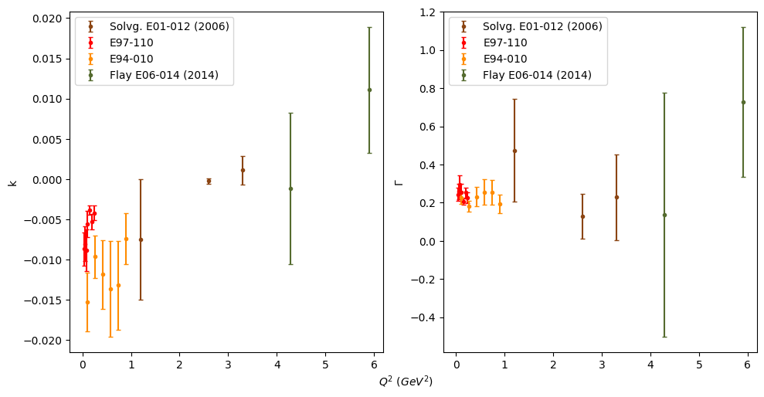
  + k versus Q2 looks linear while gamma versus Q2 looks like a constant or maybe an exponential

Monday July 15, 2024 (4)

* Made slides for tomorrow’s meeting
* Tried to refit Flay data - got an ok fit for Q2=5.9 but not for Q2=4.29
* Tried fitting k with a logarithmic function, but so far it doesn’t work

Sunday July 14, 2024 (2)

* Plotted k and gamma parameters versus Q2, except for Flay - not enough points for a good fit

Saturday July 13, 2024 (2)

* Plotted resonance data for each Q2 and fit for data under W=1.6 since there’s another resonance at W=1.8

Friday July 12, 2024 (3)

* Looked up correlation vs covariance - like Xiaochao said, pcov[i][j] = corr[i][j] * sigma[i] * sigma[j]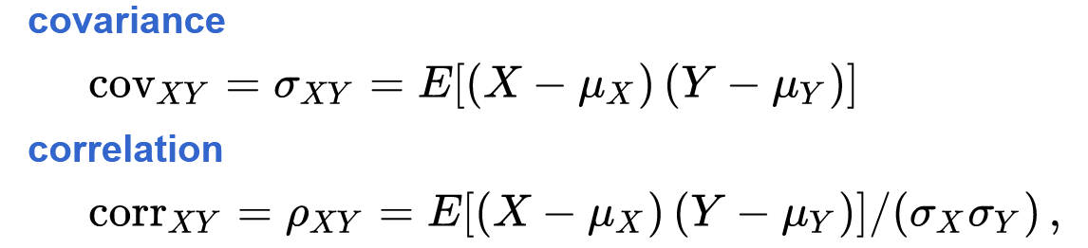
* Fixed fit uncertainty code and got new plot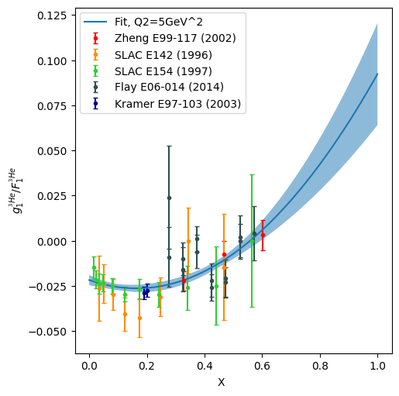
* Started trying to fit resonance data
  + Decided to split Flay’s data into 2 buckets since all of its data are different Q2

Wednesday July 10, 2024 (2.25)

* Saved plot of g1f1 dis fit
* Recorded g1, g2 values from Kevin Kramer’s [dissertation](https://inspirehep.net/files/6730bded7d074e11a11f17e163303fbf) (E97103)
* Interpolated F1 for Kramer’s data and calculated g1/F1, and g2/F1
* Fit with e97103 data 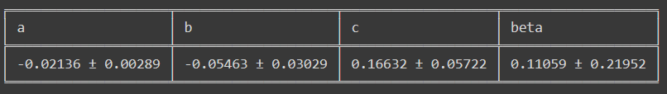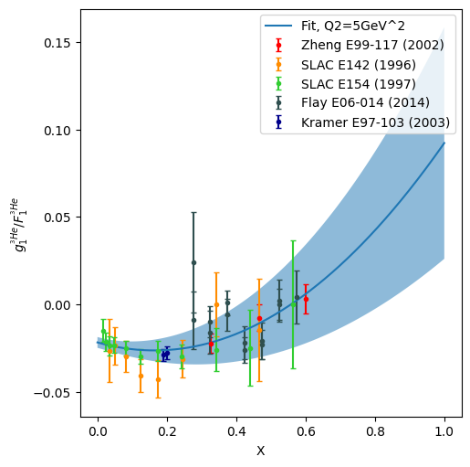
* Need to fix zero uncertainties in e94010 data before fitting resonance

Monday July 8, 2024 (4)

* Neutron fitted parameters from Xiaochao’s thesis: 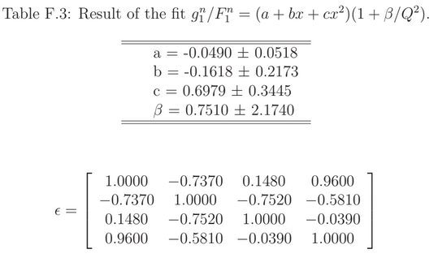
* Results from fitting g1/F1 for 3He: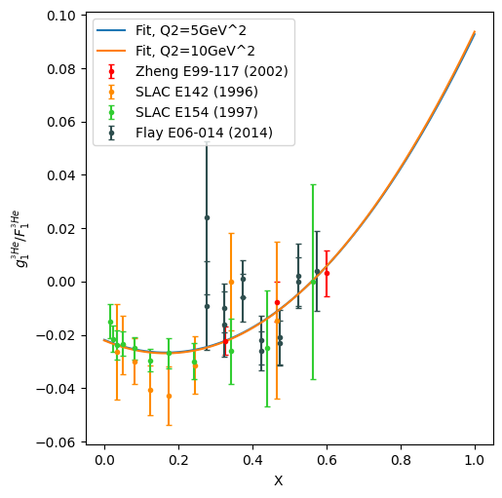

| a | b | c | 𝛽 |
| --- | --- | --- | --- |
| -0.022 ± 0.0038 | -0.06 ± 0.0333 | 0.17 ± 0.064 | -0.1 ± 0.47 |

* Plotted Mingyu’s thesis data on top of the fit for Xiaochao
* Determined error in the fit using equation F.5 from Xiaochao’s thesis
  + Note: she uses a correlation matrix - had to sub in 1.0 for the diagonal elements in the equation

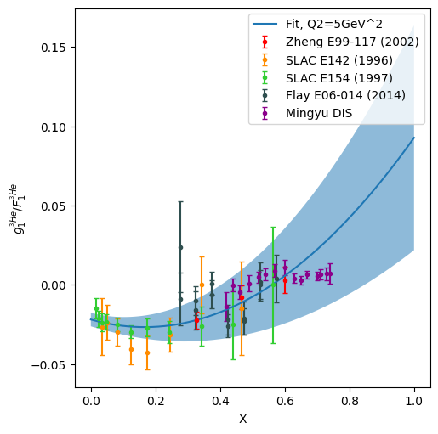

Tuesday July 2, 2024 (4)

* Corrected Eb in dflay e06014 from 4760 to 4740
* Found fits used in Xiaochao’s thesis for the proton and neutron (Appendix E)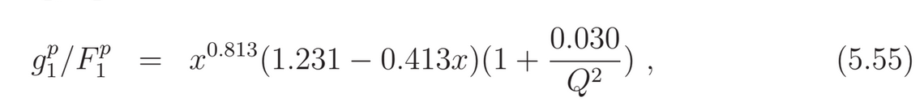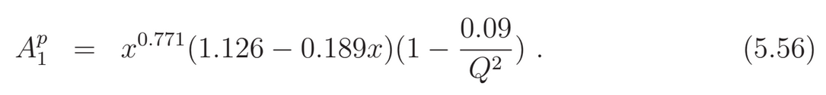
* E155 fit (Appendix E)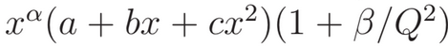
  + Factor of *xa* accounts for gluon distribution at small *x* - fits with this factor did not work well for high *x* data (x>0.61)
* She also tried several other forms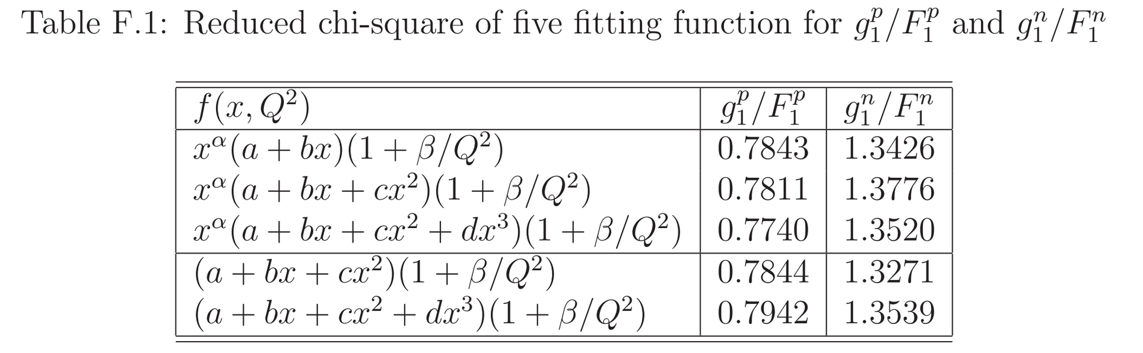
* Appendix E also talks about how to quantify error of fits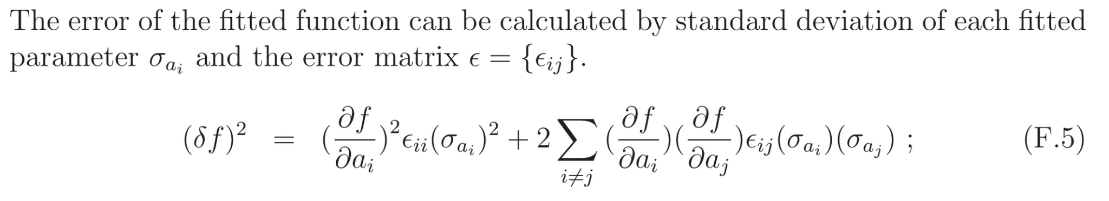
* g1/f1 and A1 for 3He in DIS region looks similar to to g1/f1 neutron fit in Zheng’s thesis
* Attended zoom call
  + Xiaochao suggests using neutron fit
  + Resonance form from slack general chat
    - 1232 peak depends on Q2 - **should fit for each data collection (different Q2), and plot the peak vs Q2 - should be able to figure out the dependence**
    - **Could do 2 peak fits (W=1.232 and W=1.8)**
  + Focus on g1/f1 since g2 can be retrieved from g1 via integration

Sunday June 30, 2024 (2)

* Finished plotting all data for A1, A2, g1/F1, g2/F1 in resonance and DIS regions - also tidied up notebook a bit

Thursday June 27, 2024 (4)

* Combined g1f1 data from zheng, e142, e154, psolv_g1g2, e97110, e94010, dflay_e06014 into one csv file (g1f1_comb.csv)
* Plotted g1f1 for DIS and resonance regions - adjusted x axis limits for DIS and y axis limits for resonance
* Plotted g2f1 for DIS and resonance regions - large errors at large W

Wednesday June 26, 2024 (4)

* Interpolated F1 for Solvignon’s thesis - had to do it based off of Q2 and X
  + No difference between using X or W for interpolation for e142 and e154
* Calculated g1/F1 and g2/F1 for e142, e154, and e97110 (.cal headers)
* e01012.csv seems to have duplicate data for A1 from psolv_a1a2.csv - just gonna use psolv data
* Converted W to GeV for dflay_e06014.csv, e94010.csv

Tuesday June 25, 2024 (4)

* Recorded g1, g2 from Solvignon’s thesis into psolv_e01012_g1g2.csv
* Can’t find anything else for E01012
* Joined He3 model meeting - should make presentation for next meeting
* Interpolated F1 for e142 and e154 using XZ_table_…_AC11.csv

Monday June 24, 2024 (1)

* Found values for g1, g2 in Patricia Solvignon’s thesis, but they are interpolated from polarized cross section differences at constant Q2 using mass of the nucleon

Wednesday June 19, 2024 (4)

* Found paper for SLAC E-142 ([link](https://inspirehep.net/files/fe502fb895ecf347ea10d8f7d526e168))
  + Has values for A1, A2, g1, g2 for He3
  + Recorded in slac_e142 excel sheet - calculated W
  + **Need to interpolate F1 for this data**
* Calculated mass of He3 nucleus as 2.8006735 GeV/c2 [(3.0149322 u - 0.0082856599 u) * 931.49410372 MeV/c2u]
* 2000 Hermes publication takes data from 1995-1997 while the thesis has data from 1995 - use the publication’s data
* Yury Kolomensky thesis for SLAC E154 ([link](https://inspirehep.net/files/5837438e365534e9d3fc7225f13260dd)) has Apara and Aperp for He3
  + Text file from Xiaochao has A1 and g1 (g1 evolved to Q2 = 5 GeV2 for const g1/F1)
* Checked rest of the web data files - all are empty of measurements for He3
* Updated readme

Tuesday June 18, 2024 (4)

* E06014 publication does not present A2 or g2/F1 values but flay’s thesis does
  + A1 and g1/F1 values are the same between the two
* Fixed errors in zheng csv (should’ve been added in quadrature)
* Finished getting data from Zheng’s thesis and e06014 (zheng_thesis_pub_e99117.csv AND dflay_e06014.csv)
* Ralf Kaiser [thesis](https://summit.sfu.ca/item/7253) (HERMES) - A1 and Apar values
  + Q2 from collaboration publication ([link](https://arxiv.org/pdf/hep-ex/9703005))
  + Can’t find W values - tried calculating using equation from the crash course, but don’t have a reliable value for Mp
* A1he-hermes~.txt seems to be an earlier version of A1he-hermes.txt ([paper link](https://arxiv.org/pdf/hep-ex/9906035))
  + Similar data points as the above thesis and publication - not sure if they’re from the same experiment (was HERMES one experiment?)
  + Recorded both in hermes excel sheet - need to check if W is correct and whether these may be duplicate data

Monday June 17, 2024 (3)

* Made readme file for documenting zheng data and web data on my machine
* Mohhamed fixed values for dflay aphysical and g2f1 csv files
  + Created an excel sheet to combine the two - also recorded g1f1 and error (added systematic and statistical in quadrature)
* e06014 file has A1 & g1f1 values from the publication - should add A2 & g2f1 and check with thesis values

Friday June 14, 2024 (5)

* Met with Xiaochao
  + Plotting by Q2 won’t be very helpful
  + Want to try to fit A1/A2 OR g1/F1 and g2/F1 (latter being more convenient) - see message in slack
  + Looks like duplicate data points in e01012 - **Patricia Solvignon’s thesis has multiple values for A1 at the same W, but different Q2 (x)**
* Mohammed fixed interpolation for F1,F2 by just using inelastic columns for E97-110
* Recorded values for A1, A2, g1, g2, g1/F1, g2/F1 from [Zheng’s published thesis](https://arxiv.org/pdf/nucl-ex/0405006):
  + Kept unrounded values for A1, A2, g1, g2, g1/F1, g2/F1, x, and Q2 from original thesis (tables 6.2,6.3, 6.4)
  + Recorded new values for Apara and Aperp (table 7)
  + Calculated Nu from beam energy and E’
  + Took square root to get W from W2

Thursday June 13, 2024 (3)

* Read through section on detectors in the crash course
* Read through some of the section on A1 and A2 in Xiaochao’s thesis
* Did some more plotting - added plots for different Q2 buckets which I can change

Wednesday June 12, 2024 (4)

* Read up to section on detectors in the crash course - tried problem 9
* Read through some of Xiaochao’s thesis
* Plotted g1/F1 for E94-010 in the same manner as I did for E97-110 - need to fix axes
* Modified plot for E06-014 - removed extra subplots and plotted each beam energy in its own subplot

Tuesday June 11, 2024 (5)

* Read through summer lecture up to page 21
* Tried splitting plot for E97-110 by different beam energies (3 different plots)
* Mohammed says to do 7 different plots
* Plotted g1/F1 for E97-110 in its own figure, each energy/Q2 as its own subplot

Monday June 10, 2024 (3)

* Finished plotting A1 vs W
* Adjusted plot for g1f1 for E06-014
* Worked on plot for g1f1 for E91-110 - separated into two plots with different tiers of beam energies (maybe I should separate by Q2?)
* Did problems 6 and 7

Friday June 7, 2024 (1.5)

* Improved code and made the different energies for the first A1 plot distinguishable

Thursday June 6, 2024 (3)

* Met with Xiaochao - csv files seem to be mostly complete except for Xiaochao’s thesis
* Should color code points according to beam energy, give a plot legend and change y axis to make points easier to see

Wednesday June 5, 2024 (4)

* Read up to page 16 in the summer crash course
* Did some of problems 1-3
* Looked at data for g1/F1 and set up plot in google colab
* Xiaochao says we need to make sure we have all the data from the publications/theses

Tuesday June 4, 2024 (1:35)

* Made new colab notebook for plotting
* Downloaded the csv files and readme collected by Mohhamed and uploaded to google drive
* Set up notebook to mount my drive and open the csv files with pandas
* Plotted A1 vs W with error bars for the two files that have A1 data (according to readme)